Sprint 3 Completion Report
KPI Definition & Dashboard Development

Objective
The objective of Sprint 3 was to define key performance indicators (KPIs) and develop an interactive dashboard to analyze intern performance, productivity, and efficiency using Power BI.
Work Completed
1. KPI Definition
Identified and defined meaningful KPIs to measure intern performance:
- Completion Rate (%)
- Average Attendance (%)
- Performance Score
- Task Completion Count
- Task Time Efficiency
- Skill Level Performance
- Department Contribution

2. Data Analysis
- Performed analysis on intern dataset
- Evaluated productivity, efficiency, and quality metrics
- Identified trends, patterns, and performance gaps

3. Dashboard Development (Power BI)
Developed an interactive Power BI dashboard with:
- KPI Cards for summary metrics
- Bar & Column Charts for comparisons
- Donut Chart for task distribution
- Scatter Plot for efficiency analysis
- Combo Chart for monthly trends
- Treemap for department contribution
- Slicer for dynamic filtering

4. Dashboard Features
- Interactive filtering (Department-wise)
- Visual representation of trends and insights
- User-friendly layout and design
- Real-time data exploration capability

Key Insights Generated
- Performance varies across months with peak productivity periods
- Medium-level tasks dominate over high-level tasks
- Skill gap exists between beginner and advanced interns
- Certain departments contribute more than others
- Time spent does not always correlate with efficiency

Tools & Technologies Used
- Power BI (Dashboard & Visualization)
- Microsoft Excel (Data preprocessing & cleaning)

Outcome
- Successfully transformed raw data into meaningful insights
- Built a visually appealing and interactive dashboard
- Enabled data-driven decision making for performance improvement
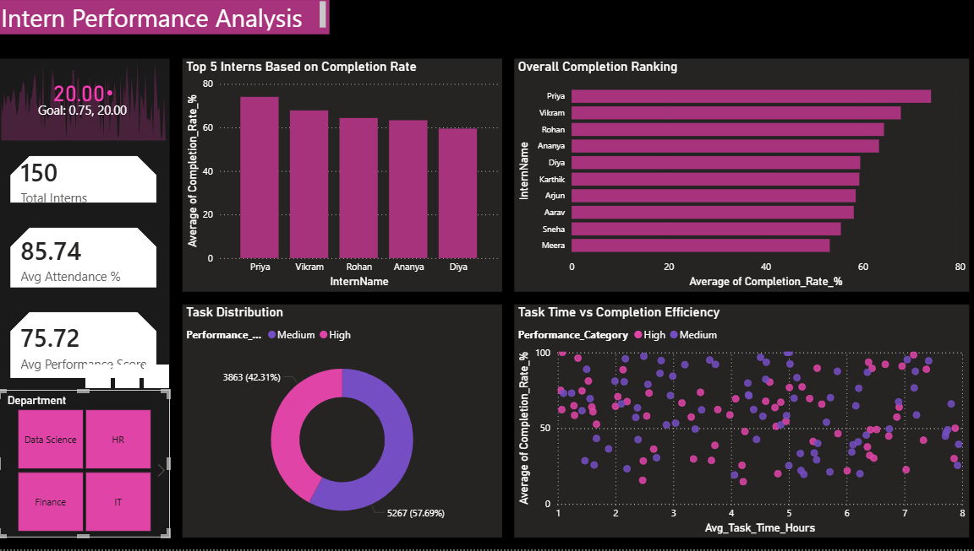
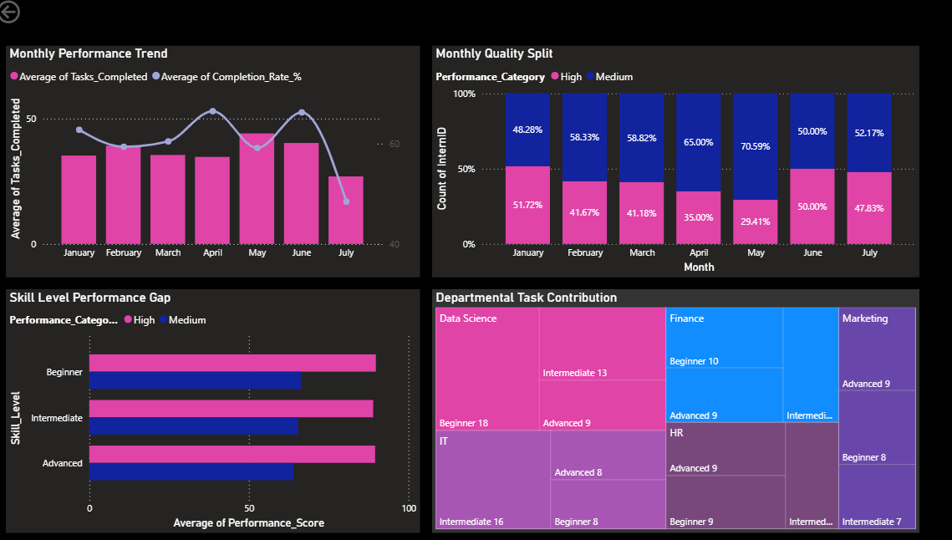

Conclusion
Sprint 3 was successfully completed by defining KPIs, analyzing data, and developing an interactive dashboard that provides clear insights into intern performance and organizational productivity.

